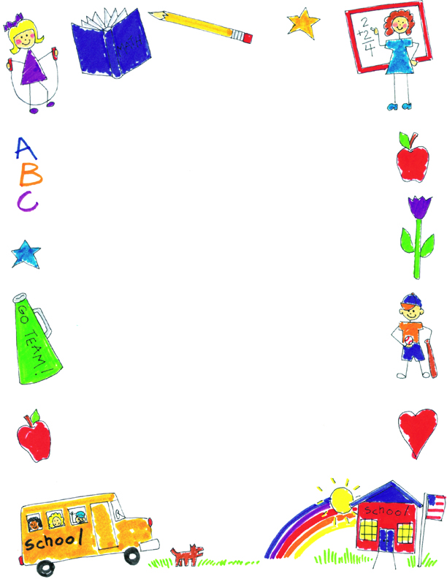

**JK Reflections by Allison**

What did you notice about your self-portraits?

My last one looks most like me. I have long, blond hair, blue eyes, fingers, rainbow clothes, and shoes. I like this one best because I put more things on it.

What was your favorite project?

My favorite project was reading Owl Moon and making the owls. I liked putting the owl’s eyes on best.

What was your favorite memory?

My favorite memory is Beach Day and Halloween. On Beach Day, we made ice cream and we went swimming in the pools. On Halloween, I liked dressing up for the parade.

What did you learn in JK?

I learned how to do Letterbooks, how to write my name the “JK way”, and how to be kind to others with kind words.