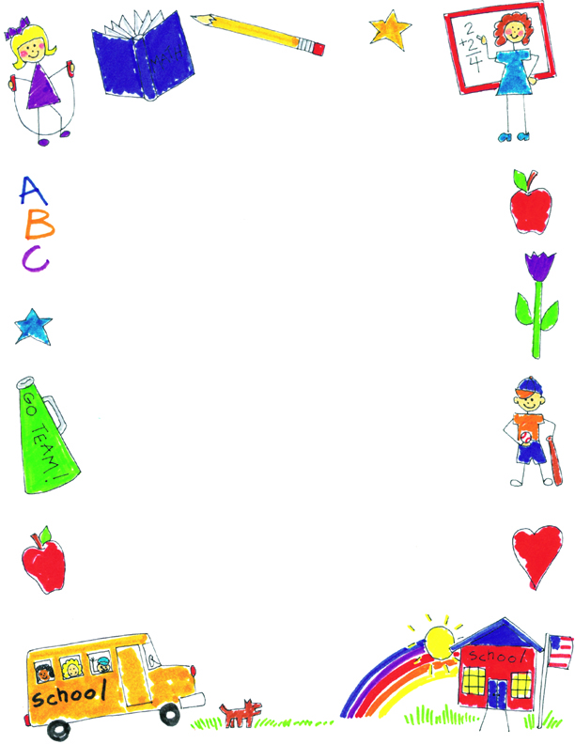

**JK Reflections by Henry**

What did you notice about your self-portraits?

I like the last one better because I have eyelashes, clothes, hands, hair and shoes.

What was your favorite project?

My favorite project was the menorah project because I got to paint and put my handprint on it.

What was your favorite memory?

My favorite days were Halloween and Beach Day because we got to dress up and be in the Halloween parade in the gym. On Beach Day, I got to swim in the swimming pool.

What did you learn in JK?

I learned how to make a butterfly and how it grows. I also liked letting the butterflies go free too.