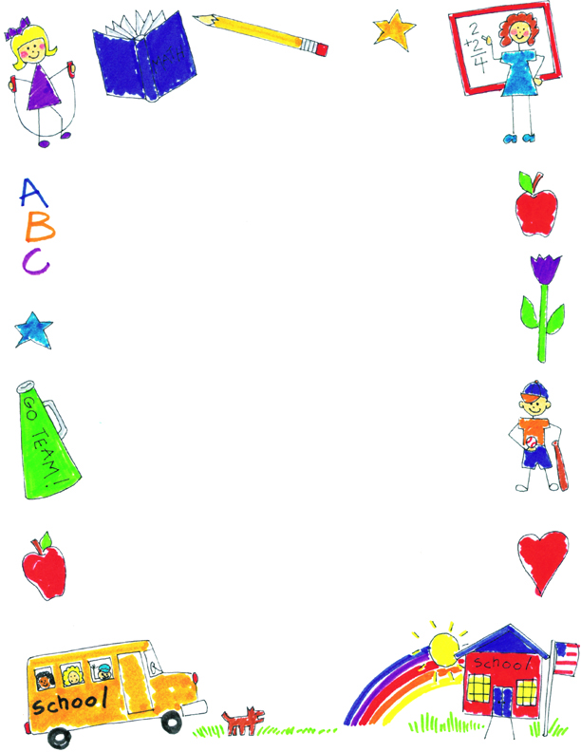

**JK Reflections by Jayden**

What did you notice about your self-portraits?

I put more things on the last one so it was better. I also put more color on it. The last one is the best because I learned how to make a person with lots of stuff on it.

What was your favorite project?

My favorite project was the “Five Little Pumpkins” and the Frankenstein monster hand print. I like the Halloween ones.

What was your favorite memory?

My favorite activity was when we decorated cookies. I really liked to eat them too. It was fun to put icing and sprinkles on them.

What did you learn in JK?

I learned how to write my letters and make words. I am learning to be a reader.