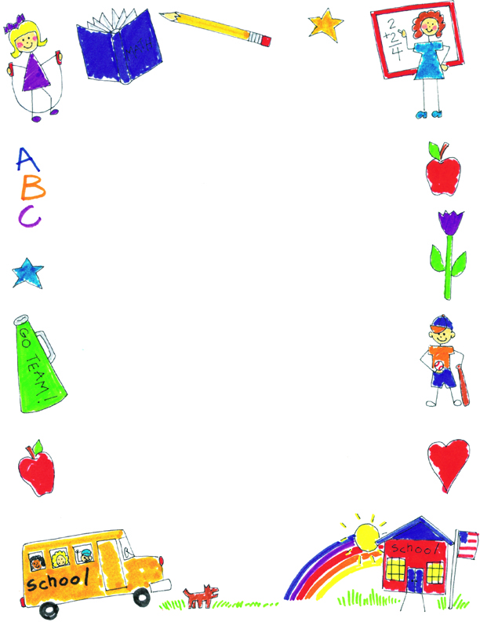

**JK Reflections by Jack**

What did you notice about your self-portraits?

They got better because I keep getting smarter. I added some ears, a body and shoes on the last one.

What was your favorite project?

My favorite ones were the ones that were easy…like the Lorax project. It was my favorite because it was really easy.

What was your favorite memory?

My favorite day was the Thanksgiving Feast because we got to have cookies. They’re my favorite. I really like candy sweet things.

What did you learn in JK?

I learned letters and how to write them. I feel like I can write lots of things now.