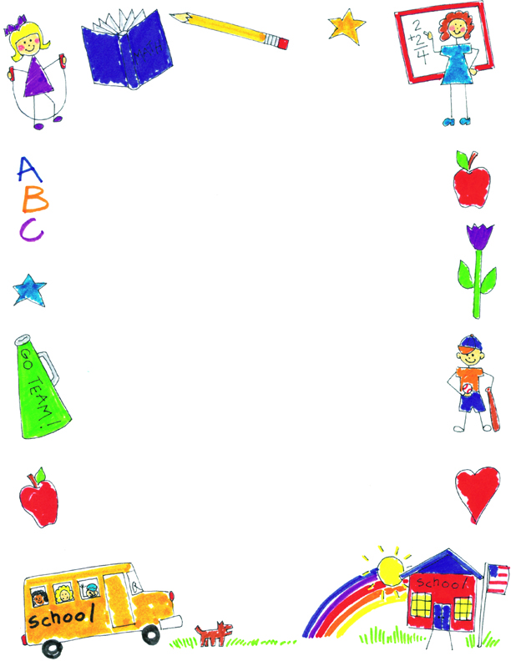

**JK Reflections by Juliana**

What did you notice about your self-portraits?

They got better because I “drawed” more details with it. My favorite one is the spring one because I’m wearing a crown in it.

What was your favorite project?

The snail heart project is my favorite because I liked the colors pink and green and the hearts. Valentine’s Day is fun.

What was your favorite memory?

My favorite day is when we had the Halloween parade because we had a party, got dressed up and had a parade. I liked the games and the food too.

What did you learn in JK?

I learned how to play nicely with Ava and Allison, how to write my name, and words that begin with all the letters.