Your link to 3- D virtual Smithsonian exploration this week:
https://3d.si.edu/collections/cerroballena
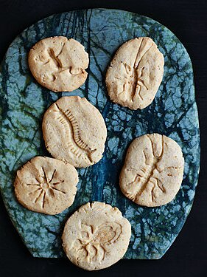

Hello Kindergarten and first grade families,
Greetings from the virtual art class! I hope you enjoyed last week’s color wheel scavenger hunt (1st) and Earth Art activity (KG) If you haven’t gotten a chance to try these projects yet, please do, as they are great interactive projects for you and your child.
If you have completed last week’s work, here is a great way to continue AR learning while at home. Here are some fascinating fossils to study from all angles. I hope you will encourage your child to experiment with fossil-making while at home. Here are some ideas:

https://www.fantasticfunandlearning.com/fossil-fun-for-kids.html
https://www.marthastewart.com/345396/fossil-cookies

Have a great week!
If you would like to share your creations, please email to:
mreynolds@fredericksburgacademy.org
Ms. Reynolds
LS Fine Arts

