April 27, 2020
Art News
Welcome back!
I hope your week included some outdoor fun and nature walks. Many of our students celebrated Earth Day by designing an outdoor display with natural materials. Well done! If you haven’t taken a photo and emailed it yet, it is not too late. Your children are now official environmental artists; I send a big thank-you to parents who assisted with safely gathered items.
Our second graders tried a color-mixing project to create our earth without green paint. They turned out beautifully!
Our fourth graders experimented with cubism and Italian still life arrangements.
THIS WEEK
Students will be exploring online art galleries through PBS and follow with activities related to certain works of art.
https://www.pbs.org/newshour/arts/19-immersive-museum-exhibits-you-can-visit-from-your-couch
Younger students will enjoy browsing with you. Please offer observations that elicit reactions from them, such as “What is happening in the boat?” and “How do you think the child feels by the expression on her face?” rather than telling them what they should see or feel. Each work of art is a mystery and your child is an art detective, searching for clues to understand the content, atmosphere, mood, time period, art style, and historical significance.
Older students will be selecting two pieces to reflect and record observations in their art journals.
Thank you for helping with this virtual art class! Specific grade-level directions to follow. If you would like to share the resulting work, please email artwork with the child's name and classroom in the photo.

Sincerely,
Mirinda Reynolds
LS Fine Arts
mreynolds@fredericksburgacademy.org

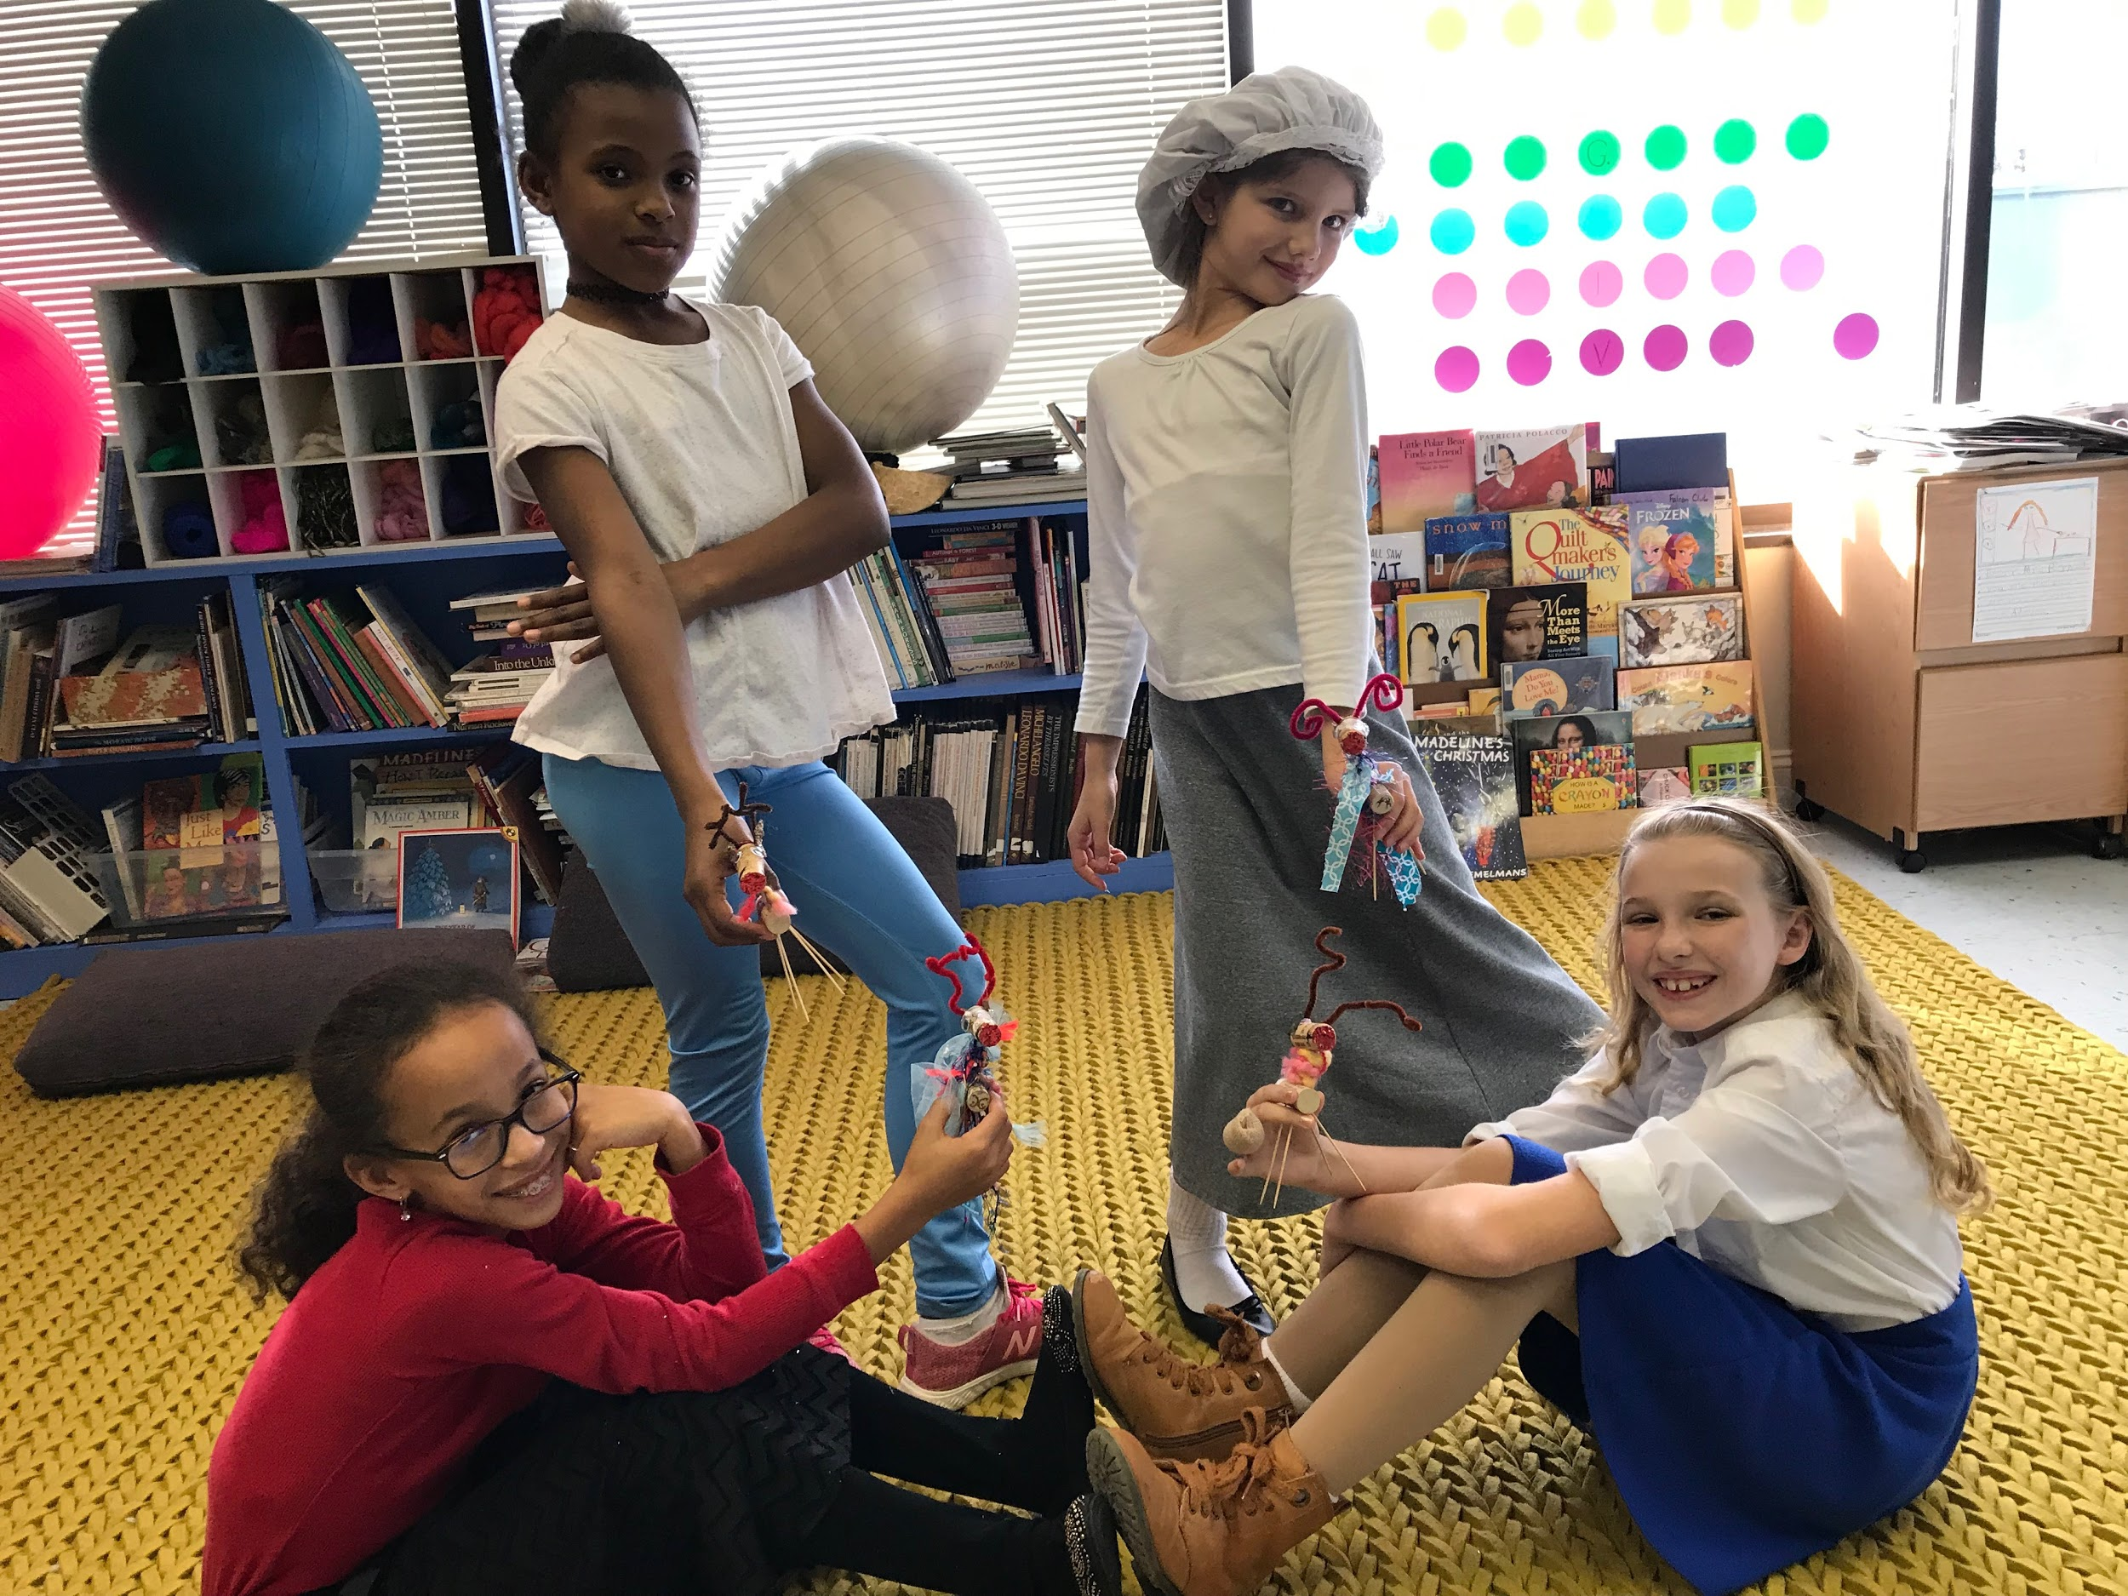

Art Flashback: Current 5th graders sharing a reindeer physics challenge
in the art room December 2018

