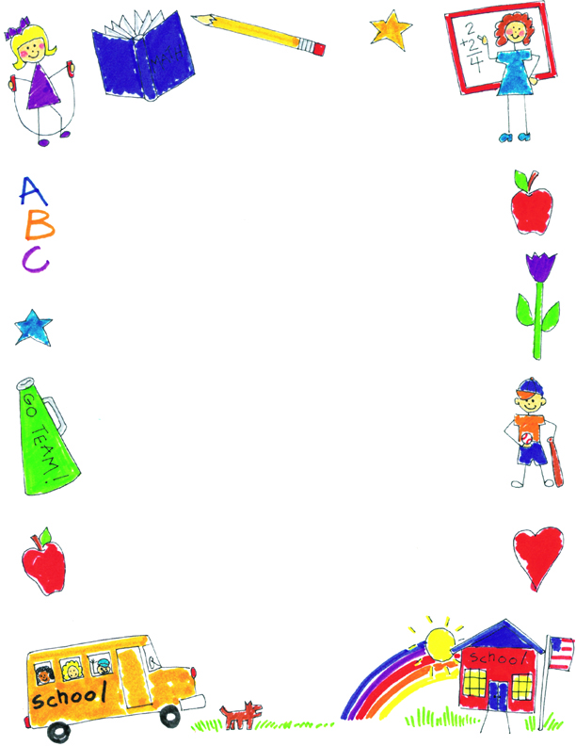

**JK Reflections by Lewis**

What did you notice about your self-portraits?

The last one has feet, hands, teeth and eyebrows. I made the last one best because it looks more like me.

What was your favorite project?

My favorite project was The Snowy Day because I like pretending to play in the snow. I also like throwing snowballs with Mommy and Daddy.

What was your favorite memory?

Halloween parade was my favorite because we can dress up and get candy. I also like playing games at our party too.

What did you learn in JK?

In JK, I learned how to make letters, how to make a picture, and the sounds letters make.