Denim Day Tomorrow
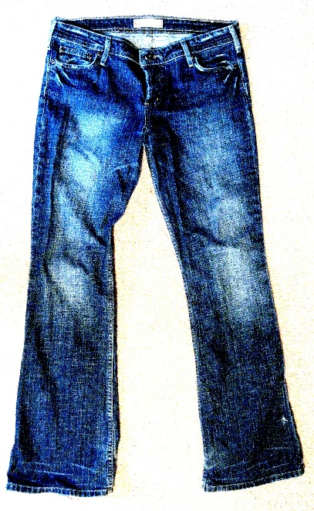
Isla Jacobson, our acting head of school thanks to a purchase at our school auction, has declared tomorrow a denim day for all staff and students!

