Third Grade Halloween Details
Thursday, October 31
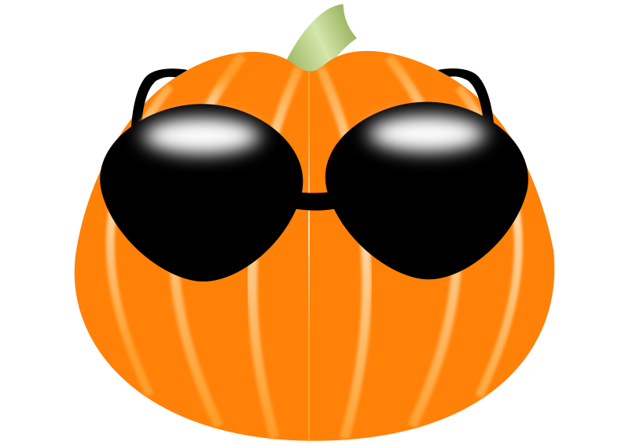
Halloween Costumes
All third graders should arrive at school in their costumes. Please make sure your child has a change of clothes and a bag large enough to store all parts of his/her costume.

Parade at 9:00 a.m.
You are invited to stop by the sports center to see all the ghosts, goblins, princesses, and other interesting characters.

Classroom Event
The third grade Halloween snack will take place immediately following the parade in the sports center. You are invited to join us in our classrooms for a small treat. Please make sure your child packs a regular snack.

