Third Grade Newsletter – October 31, 2019

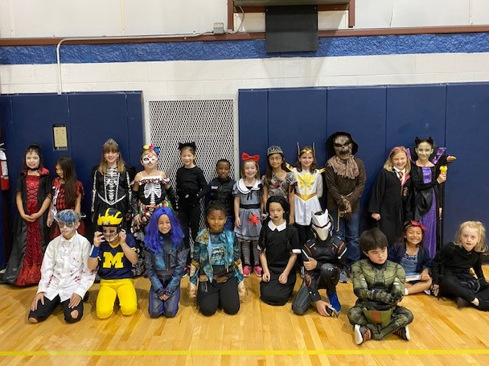

Important Dates

November 8 --------First trimester ends

November 11-------No school for lower school
students

Teacher work day

November 27-------Early dismissal 11:55 a.m.

November 28-------Thanksgiving break
Through No school
December 2

December 3---------School resumes

http://blogs.fredericksburgacademy.org/thirdgrade/

Our week
We started the week by celebrating Halloween.
Thank you to the room parents for providing such
wonderful classroom snacks. We appreciate all of
your support.

This week we finished some of the novels in our
book clubs and completed a creative writing project. We had a great time writing our
We are also working hard on our first Wordly Wise
lesson. Please remember that your children will be
tested on the definitions, not on the spelling. Please
help your children remember to review the Wordly
Wise flashcards.

Treats for Troops
The third grade is partnering with Soldiers' Angels Treats for Troops Program to ship donated candy to deployed service members around the world. Please drop off any candy (including extra Halloween candy!) to a third grade classroom, the Falcon’s Nest, the LS front desk, or with Mrs. Walsh in the US. We are collecting until November 5th.
Reminders
- Did you know that hydration improves learning and concentration? Please help
your child remember to bring a water bottle to school each day.
- Please help your children label their belongings (jackets, gloves, lunchboxes, etc.) Thank you for making sure your child completes all homework each night. We appreciate your support!

