Penny Harvest
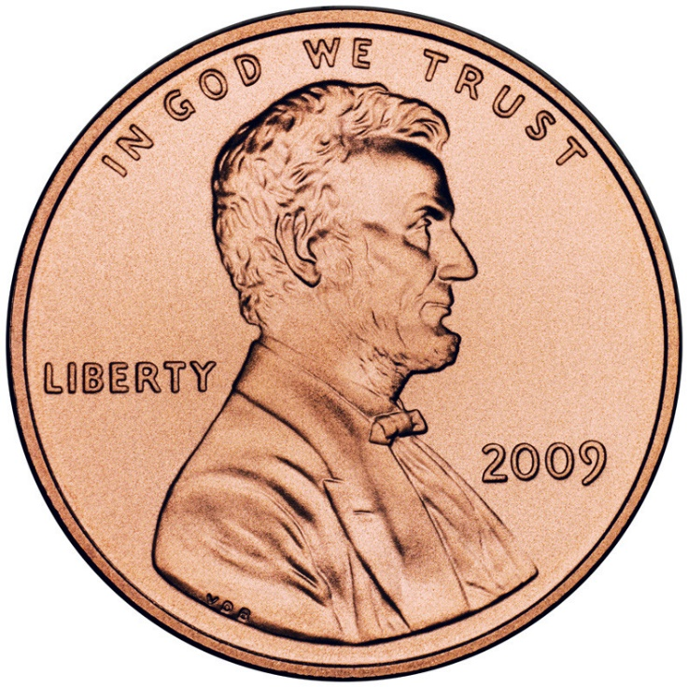

Each student in the Lower School is bringing a small water bottle home today. Drink the water, allow the bottle to dry, and fill it with pennies to return to the second grade classroom. Students will collect pennies all year and will donate the money to a local charity in May. Last year, students donated money to the SPCA and to Mrs. Estes for new items for our playscape.

