Third Grade Newsletter – November 27, 2019

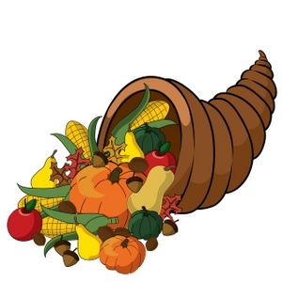

We had a great week sharing our lab reports with the upper school Chemistry students, finishing our science unit on matter, making our own thesauruses, reviewing time on an analog clock, and making a variety of graphs in math.

We hope you have a wonderful Thanksgiving. Thank you for trusting us with your children each day. We are very thankful for you!

Important Dates
.

November 28-------Thanksgiving break
through No school
December 2

December 3---------School resumes

December 7---------Holiday breakfast

December 20-------Early dismissal at 11:55 a.m.
Holiday program

December 23-------Holiday break
through No school
January 3

January 6-----------School resumes

http://blogs.fredericksburgacademy.org/thirdgrade/

