Third Grade Newsletter – November 8, 2019

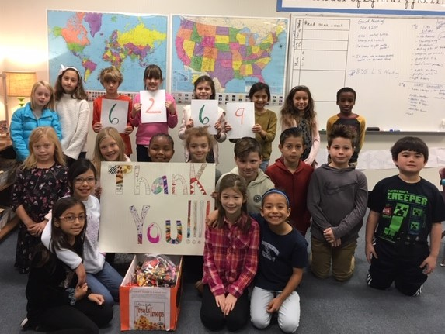

Treats for Troops Update
Thank you to everyone who helped make our Soldiers' Angels Treats for Troops Program such a success! We had a great time counting and weighing the candy. As a school, we collected 6,269 pieces of candy. The lower school collected 4,682 pieces, the middle school collected 875 pieces, and the upper school collected 712 pieces. A special thank you to Sedona Taphouse for covering the shipping costs to send the candy to the troops.
Wordly Wise Update
Wordly Wise tests came home in Friday folders today. Please remember that this is a new program for all students, and that it will take time and practice for students to perform to the best of their abilities. If your child’s score is lower than you expected, please remember that improvement will come with daily review as noted in the assignment book. We will begin the next Wordly Wise unit on Tuesday.

Report Cards
The first trimester ended today. This trimester third
grade report cards will be placed in
backpacks next week.

Reminders
- Please watch the weather closely and send in outerwear appropriate for the weather.
- Please help your children label their belongings, including jackets, gloves, and lunchboxes.
- Thank you for making sure your child completes all homework each night. We appreciate your support!
Important Dates

November 11-------No school for lower school
students

Teacher work day

November 27-------Early dismissal 11:55 a.m.

November 28-------Thanksgiving break
Through No school
December 2

December 3---------School resumes

http://blogs.fredericksburgacademy.org/thirdgrade/

