Student Information for Field Trip
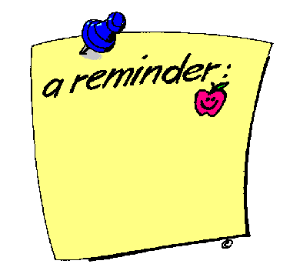
- Your child should be at school at 8:15 a.m. We will board the bus promptly at 8:30 a.m.
- Please dress for the weather. A large portion of the field trip is outside. Jeans and sneakers are permitted.
- Your child should pack a SNACK
  - IN A SEPARATE BAG (disposable or reusable) labeled with name.
  - Include everything you need---utensils, napkins, and a drink.
  - This will be carried onto the bus and eaten on the bus ride.
- Your child should pack a LUNCH
  - IN A SEPARATE BAG (disposable or reusable) labeled with name.
  - Include everything you need, including utensils, napkins, and a drink.
  - We will eat this at Mount Vernon.
- Your child is permitted to bring one bag with a few books for the bus ride. Electronics are not permitted. Bags will be left on the bus.
- We do not visit the gift shop during our trip. Students should not bring any money.

