Third Grade Newsletter—February 21, 2020

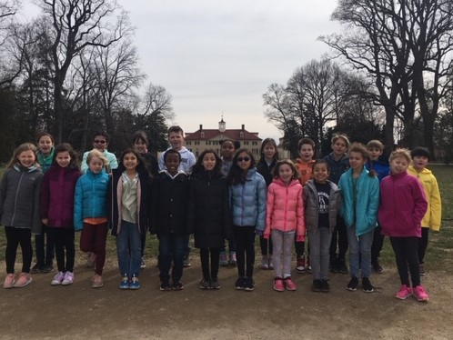

Update
This week we concluded our unit on George
Washington. We had a great time reviewing our facts by playing classroom Jeopardy, writing a non-fiction journal entry, preparing for our blogs, and of course visiting Mount Vernon. Throughout our visit to Mount Vernon we received several compliments from staff members. At the conclusion of the tour, our tour guide said, “It was truly a pleasure to be with a group of such well-behaved and knowledgeable children.” We have a wonderful time. Thank you for helping your child prepare for the field trip.

Performance Costumes
Students have been working hard to prepare for their big performance on March 12. For both the morning and evening performance, students should dress in dark pants and a top in the following colors:

Mrs. Llufrio’s class: any shade of red
Mrs. Rosnick’s class: any shade of blue

Report Cards
Second trimester report cards are in your child’s orange folder.

Spring Conferences
Spring conferences will be on March 13, which is the day after our performance. Conference sign up opportunities will be available when we return from our winter break. We will send out links to Google documents at that time. We look forward to meeting with you to discuss your child’s progress in third grade!

Important Dates

February 24-28 Winter Break—No School

March 12 Third grade performance
9:00 a.m. and 7:00 p.m.

March 13 Parent-Teacher Conferences
No school

Our blog:
http://blogs.fredericksburgacademy.org/thirdgrade/

November 11 Wear a green, blue or FA shirt!
November 18 International Club after school
Junior Master Gardeners after school
(students will select one to attend)

November 25 11:45 a.m. dismissal
November 26-30 No School
December 18 Lower School Holiday Program 11:45 a.m. dismissal

